Financial News Sentiment and Stock Price Prediction using NLP and Deep Learning: LSTM, Transformer & Explainable AI

A Project Stage – I Dissertation submitted to the Jawaharlal Nehru Technological University, Hyderabad in partial fulfillment of the requirement for the award of a degree of

BACHELOR OF TECHNOLOGY
IN
CSE(ARTIFICIAL INTELLIGENCE AND MACHINE LEARNING)

Submitted by

B. Anirudh Reddy 23B81A6669
Y. Eeshanya 23B81A6679
Sk. Mehawish Fathima 23B81A6680

Under the guidance of
Mrs. Farhana Bano
Sr.Assistant Professor

DEPARTMENT OF CSE(ARTIFICIAL INTELLIGENCE AND MACHINE LEARNING)
CVR COLLEGE OF ENGINEERING
(An Autonomous Institution, NAAC Accredited and Affiliated to JNTUH, Hyderabad)
Vastunagar, Mangalpalli (V), Ibrahimpatnam (M),
Rangareddy (D), Telangana- 501 510

October 2026

CVR COLLEGE OF ENGINEERING
(An Autonomous Institution, NAAC Accredited and Affiliated to JNTUH, Hyderabad)
Vastunagar, Mangalpalli (V), Ibrahimpatnam (M),
Rangareddy (D), Telangana- 501 510

DEPARTMENT OF CSE(ARTIFICIAL INTELLIGENCE AND MACHINE LEARNING)

CERTIFICATE
This is to certify that the Project Stage – I report entitled “Financial News Sentiment and Stock Price Prediction using NLP and Deep Learning: LSTM, Transformer & Explainable AI” is a bonafide record of work carried out by B. Anirudh Reddy (23B81A6669), Y. Eeshanya (23B81A6679) and Sk. Mehawish Fathima (23B81A6680) under the guidance of Mrs. Farhana Bano, Sr. Assistant Professor. This report is submitted in partial fulfilment of the requirements for the award of the degree of Bachelor of Technology in CSE(Artificial Intelligence and Machine Learning) to CVR College of Engineering, affiliated to Jawaharlal Nehru Technological University, Hyderabad, during the academic year 2026-27.

Project Guide  Mrs. Farhana Bano,  Sr. Assistant Professor  Department of CSE(AI&ML) | Project In-Charge  Dr. D. Ratnam,  Sr. Assistant Professor  Department of CSE(AI&ML)
Dr. R. Usha Rani
Professor & Head
Department of CSE(AI&ML)

DECLARATION

We hereby declare that the Project Stage – I report entitled “Financial News Sentiment and Stock Price Prediction using NLP and Deep Learning: LSTM, Transformer & Explainable AI” is an original work carried out and submitted by us to the Department of CSE(Artificial Intelligence and Machine Learning), CVR College of Engineering, affiliated to Jawaharlal Nehru Technological University, Hyderabad, in partial fulfilment of the requirement for the award of the degree of Bachelor of Technology in CSE(Artificial Intelligence and Machine Learning). This report is a bona fide record of the project work completed under the guidance of Mrs. Farhana Bano, Sr. Assistant Professor, Department of CSE(Artificial Intelligence and Machine Learning).
We further declare that the work reported in this project has not been submitted, either in part or in full, for the award of any other degree or diploma in this Institute or any other Institute or University.

Signature of the Student
B.Anirudh Reddy

Signature of the Student
Y. Eeshanya

Signature of the Student
Sk. Mehawish Fathima

Date:
Place:

ACKNOWLEDGEMENT

We are happy to present our project stage – I dissertation titled “Financial News Sentiment and Stock Price Prediction using NLP and Deep Learning: LSTM, Transformer & Explainable AI”, completed as part of our curriculum in the Department of CSE(Artificial Intelligence and Machine Learning), CVR College of Engineering.
We respect and thank our internal guide, Mrs. Farhana Bano, Sr. Assistant Professor, Department of CSE(Artificial Intelligence and Machine Learning), for giving us all the support and guidance, which helped us complete the project duly.
Our sincere thanks to the members Dr. D. Ratnam of the Project Review Committee for their valuable guidance and support, which greatly contributed to the successful completion of our project.
We would like to express heartfelt thanks to Dr.R.Usha Rani, Professor and Head of the Department, for providing us with an opportunity to do this project and extending support and guidance. Our gratitude also extends to Dr. Lakshmi H. N, Associate Dean, First Year Engineering, for her encouragement to complete the project work.
We are thankful to our Vice-Principal, Prof. L. C. Siva Reddy, for providing excellent computing facilities and a disciplined atmosphere for our work.
We wish a deep sense of gratitude and heartfelt thanks to Dr. K. Rama Mohan Reddy, Principal, and the Management for providing excellent lab facilities and tools.
Finally, we are thankful for and fortunate enough to get constant encouragement, support, and guidance from all Teaching staff, Department CSE (AI&ML), which helped us complete this project work.

ABSTRACT
Stocks are driven by a whole host of things: historical price action, the state of the economy, company performance, investor behaviour and financial news. Getting a reliable prediction of stock prices is a very difficult proposition as the market is constantly in flux and influenced by both numbers and news. The conventional approach to stock prediction is to use historical market data. Some of the more recent approaches attempt to combine news sentiment with stock price in a single model. The problem with many of these is that they don't really explain what it is about the data that's leading to the prediction. This is an integrated and explainable stock price prediction framework using NLP, Deep Learning and XAI. It takes historical stock market data (Open, High, Low, Close, Volume) and technical indicators (RSI, MACD, SMA, EMA) and combines that with financial news headlines. The news headlines are processed via FinBERT (a pre-trained language model) to produce a positive, negative or neutral sentiment classification. That sentiment is then combined with the market data to form an integrated dataset for the prediction. The proposed framework utilises two deep learning models (Long Short Term Memory (LSTM) and Transformer) to predict stock prices and compare their performance. The models are evaluated using a range of standard metrics (MAE, RMSE, R² Score) and SHAP (SHapley Additive exPlanations) is used to determine the contribution of each of the various market indicators and news sentiment features to the individual predictions. The results will be presented in an interactive dashboard which will show the predicted stock prices, the news sentiment, the model performance and the feature explanations. This Stage-I report contains the problem definition, literature survey, research gap, proposed methodology, system architecture, detailed design and the implementation plan for Stage-II. The proposed system is intended to improve stock price prediction by combining financial news sentiment with historical market data and providing an explanation of the model's predictions that is understandable to a human.
Keywords: Stock Price Prediction, Financial News Sentiment Analysis, FinBERT, LSTM, Transformer, SHAP, Deep Learning, Explainable AI.
Domain:Artificial Intelligence and Machine Learning / Financial Technology.
Method: Natural Language Processing (NLP), FinBERT Sentiment Analysis, Deep Learning, LSTM, Transformer, Explainable Artificial Intelligence (XAI).
List of Figures
Figure No | Name of the figure | Page No
4.1 | Proposed methodology | 1
4.2 | System architecture | 11
4.3 | Use case diagram | 13
4.4 | Activity diagram | 13
4.5 | Sequence diagram | 14
5.1 | Gantt chart of project implementation | 18

List of Tables

Table No | Name of the Table | Page No
2.1 | Comparative analysis of reviewed literature | 6-7
3.4.1 | Functional requirements | 8-9
3.4.2 | Non-functional requirements | 9
3.4.3 | Proposed technology stack | 10
4.1 | Technology Stack and Tools
5.1 | Stage-II Module Structure

List of Abbreviations

Acronym | Abbreviation
AI | Artificial Intelligence
API | Application Programming Interface
BERT | Bidirectional Encoder Representations from Transformers
DL | Deep Learning
EMA | Exponential Moving Average
FinBERT | Financial BERT (BERT model fine-tuned for financial text)
LSTM | Long Short-Term Memory
MACD | Moving Average Convergence Divergence
MAE | Mean Absolute Error
ML | Machine Learning
NLP | Natural Language Processing
OHLCV | Open, High, Low, Close and Volume
R² | Coefficient of Determination
RMSE | Root Mean Squared Error
RSI | Relative Strength Index
SDG | Sustainable Development Goal
SHAP | SHapley Additive exPlanations
SMA | Simple Moving Average
XAI | Explainable Artificial Intelligence

TABLE OF CONTENTS
Chapter No. |  | Contents | Page No.
 |  | Certificate | ii
 |  | Declaration | iii
 |  | Acknowledgement | iv
 |  | Abstract | v
 |  | List of Figures | vi
 |  | List of Tables | vii
 |  | List of Abbreviations | viii
1 |  | Introduction | 1-3
 | 1.1 | Background of the Study | 1
 | 1.2 | Problem Statement | 1
 | 1.3 | Objectives of the Study | 2
 | 1.4 | Scope of the Project | 2-3
 | 1.5 | Relevance and Applications | 3
 | 1.6 | Organization of the Report | 3
2 |  | Literature Survey | 4-7
 | 2.1 | Introduction | 4
 | 2.2 | Review of Existing Systems/Approaches | 4-5
 | 2.3 | Comparative Analysis | 6
 | 2.4 | Research Gap Identification | 6
 | 2.5 | Summary | 7
3 |  | System Analysis | 8-11
 | 3.1 | Existing System | 8
 | 3.2 | Limitations of Existing System | 8
 | 3.3 | Proposed System | 8
 | 3.4 | System Requirements | 8-11
4 |  | System Design and Methodology | 12-18
 | 4.1 | Proposed Methodology | 12
 | 4.2 | System Architecture | 13
 | 4.3 | Use Case Diagram | 14
 | 4.4 | Activity Diagram | 15
 | 4.5 | Sequence Diagram | 16
 | 4.6 | Algorithm / Model Description | 17-18
 | 4.7 | Tools and Technologies Used | 18
5 |  | Implementation Plan for Project Stage – II | 19-20
 | 5.1 | Module Structure | 19
 | 5.2 | Project Timeline (Gantt Chart) | 19-20
6 |  | Expected Outcomes | 19
7 |  | Conclusion | 21
 |  | References | 22

CHAPTER 1
INTRODUCTION

1.1 Background of the Study
Stock markets are among the most dynamic financial systems in the world. Prices change continuously and are shaped by many interacting factors, including historical price trends, company performance, economic conditions and investor behaviour. Accurate prediction is valuable to investors and analysts but remains difficult because of the volatility and noise in market data.
Financial news is one of the strongest external influences on investor decisions. The tone of continuously reported news, such as earnings announcements and regulatory decisions, can move prices within hours. Natural Language Processing (NLP) makes it possible to analyse large volumes of financial news automatically. In particular, FinBERT, a BERT-based language model fine-tuned on financial text, can classify news headlines as positive, negative or neutral.
On the numerical side, historical stock data such as Open, High, Low, Close and Volume (OHLCV) captures market trends, and technical indicators such as the Relative Strength Index (RSI), Moving Average Convergence Divergence (MACD), Simple Moving Average (SMA) and Exponential Moving Average (EMA) add further information about momentum and trend. Deep-learning models such as Long Short-Term Memory (LSTM) networks learn patterns from time-series data, while Transformer models use attention mechanisms to capture important relationships across a sequence. Finally, Explainable AI (XAI) methods such as SHAP reveal which inputs drove a particular prediction, which is essential for trust in financial applications.
1.2 Problem Statement
Stock prices are highly volatile and are influenced by market trends, company performance, investor behaviour and financial news. Existing methods may not fully consider news sentiment alongside historical market data, and most existing models do not provide clear explanations for their predictions. There is therefore a need for a more comprehensive and interpretable stock-price prediction system that combines market data, news sentiment and Explainable AI.
1.3 Objectives of the Study
- To improve stock-price prediction accuracy by incorporating both market information and financial-news sentiment.
- To capture the relationship between financial news and stock-price movements using NLP-based sentiment information.
- To identify the most effective deep-learning approach for stock-price prediction by evaluating LSTM and Transformer models.
- To enhance the transparency and interpretability of predictions by identifying the key factors that influence the model’s output using Explainable AI.

1.4 Scope of the Project
The scope of the project covers the design and development of an integrated stock price prediction framework for selected companies. It includes the collection of historical stock market data and financial news headlines, preprocessing of the collected data, and calculation of technical indicators such as RSI, MACD, SMA, and EMA. The project uses FinBERT to classify financial news headlines into positive, negative, and neutral sentiments and combines the extracted sentiment scores with historical stock data to create a unified dataset.
The proposed system includes training and tuning two deep-learning models, Long Short-Term Memory (LSTM) and Transformer, for stock price prediction. Their performance will be evaluated and compared using MAE, RMSE, and R² metrics. The project also incorporates SHAP-based explainability to identify the contribution of market indicators and news sentiment to individual predictions. An interactive dashboard is planned to display predicted stock prices, sentiment analysis results, model comparisons, and feature explanations.
The wider scope includes improving prediction transparency by integrating numerical market information with financial news sentiment and providing understandable explanations of model outputs. The implementation will focus on selected stocks and available historical data. The final features and performance will depend on data availability, implementation feasibility, and evaluation during Stage–II.
Sustainable Development Goals (SDGs): The project contributes to SDG 8 – Decent Work and Economic Growth by supporting informed and transparent financial decision-making. It also contributes to SDG 9 – Industry, Innovation and Infrastructure by applying Artificial Intelligence, Natural Language Processing, and Deep Learning to develop an innovative, data-driven financial analytics system.

1.5 Relevance and Applications
The proposed framework has applications in the following areas:
- Individual Investors: Supports informed investment decisions through price predictions and news sentiment.
- Financial Institutions: Helps in market monitoring and risk assessment.
- Stock Market Research: Enables comparison of LSTM and Transformer models.
- Portfolio Management: Supports stock analysis using historical trends and sentiment.
- Trustworthy AI: Uses SHAP to explain the factors influencing predictions.

Sustainable Development Goal (SDG) 8 – Decent Work and Economic Growth: Supports informed financial decision-making through data-driven analysis.

Sustainable Development Goal (SDG) 9 – Industry, Innovation and Infrastructure: Promotes the use of AI and NLP in developing innovative financial analytics systems.

1.6 Organization of the Report
Chapter 1 gives the introduction and motivation. Chapter 2 presents the literature survey and research gap. Chapter 3 covers the system analysis and requirements. Chapter 4 describes the design and methodology, including the architecture and UML diagrams. Chapter 5 outlines the Stage-II implementation plan, Chapter 6 the expected outcomes, and Chapter 7 concludes the report.

CHAPTER 2
LITERATURE SURVEY

2.1 Introduction
This chapter reviews existing studies on stock-price prediction using deep learning, financial-news sentiment, technical indicators and Explainable AI. Five recent studies are examined with respect to the data they use, the models they apply, their key findings and their limitations. The review is used to identify the gap that this project addresses.

2.2 Review of Existing Systems/Approaches
1. LSTM with News Sentiment and Technical Indicators
Yang et al. [1] proposed a LASSO-LSTM model that combines technical indicators with financial sentiment analysis to predict the direction of stock prices. By combining news sentiment with stock data, the study showed that sentiment information adds value to price-based prediction. However, the work mainly focuses on LSTM and does not directly compare LSTM with Transformer models.
2. LSTM and BERT with Sentiment Analysis
Ayyappa et al. [2] used BERT to understand financial news and LSTM for equity-price forecasting. The study demonstrates the benefit of using a pre-trained language model for sentiment extraction. Its focus on a Transformer-based comparison and on explainable prediction is limited.
3. Explainable AI for Financial Decision Support
Kalra and Mittal [3] applied Explainable AI to financial trading data to make the decisions of financial AI systems easier to understand. The study highlights the importance of interpretability in finance, but it does not combine financial-news sentiment with LSTM and Transformer prediction.
4. Fusion of Technical Indicators and Sentiment Analysis
Moodi et al. [4] presented a hybrid framework that combines stock data, Twitter sentiment and technical indicators, using CNN-LSTM, LSTM and GRU models for stock-price movement prediction. The fusion of sentiment and indicators improved prediction. The study, however, does not compare LSTM with Transformer and gives limited attention to SHAP-based explanation.
5. Deep Learning and Econometrics for Stock Price Prediction
Osman and Otaibi [5] compared LSTM, Transformer, ARIMA and VAR models on daily S&P 500 data. The Transformer achieved the best overall performance, which motivates the inclusion of a Transformer in this project. The study uses mainly historical stock data and does not integrate financial-news sentiment or FinBERT.
Summary:
The existing work shows that technical indicators, news sentiment, LSTM, Transformer models and Explainable AI each improve some aspect of stock-price prediction. However, they are rarely brought together in a single framework, and the studies that combine sentiment with price data mostly rely on a single model.

2.3 Comparative Analysis Table 2.1 shows the comparative analysis of the existing literature works.
Author & Year | Methodology | Tools/Techniques | Results | Limitations
Yang et al. (2022) [1] | Stock data + financial news | LASSO-LSTM, sentiment analysis, technical indicators | Combines news sentiment with stock data to predict stock prices. | Mainly focuses on LSTM; no direct LSTM vs Transformer comparison.
Ayyappa et al. (2023) [2] | Stock data + financial news | LSTM + BERT | BERT understands financial news; LSTM forecasts equity prices. | Limited focus on Transformer comparison and explainable prediction.
Kalra & Mittal (2024) [3] | Financial trading data | Explainable AI | XAI makes financial AI decisions easier to understand. | Does not combine news sentiment with LSTM and Transformer prediction.
Moodi et al. (2024) [4] | Stock data + Twitter sentiment + technical indicators | CNN-LSTM, LSTM, GRU | Sentiment and technical indicators combined for price-movement prediction. | No LSTM vs Transformer comparison; limited focus on SHAP.
Osman & Otaibi (2025) [5] | S&P 500 daily stock data | LSTM, Transformer, ARIMA, VAR | Transformer achieved the best overall performance. | Mainly historical stock data; no financial-news sentiment or FinBERT.

Table 2.1: Comparative analysis

2.4 Research Gap Identification

Existing stock price prediction approaches often rely mainly on historical market data and lack financial news sentiment integration. Some studies combine news sentiment with stock data but use only a single prediction model. Limited research compares LSTM and Transformer models using the same integrated dataset. Additionally, many approaches lack explainability to identify the factors influencing predictions.

Therefore, this project proposes an integrated and explainable framework that combines historical stock data, technical indicators, and FinBERT-based news sentiment. It compares LSTM and Transformer models and uses SHAP to explain their predictions.

2.5 Summary
This chapter reviewed existing approaches to stock price prediction, financial news sentiment analysis, deep learning models, and explainable AI. The review identifies the need for a unified framework that combines historical market data, technical indicators, and FinBERT-based sentiment. The proposed system aims to address this need by comparing LSTM and Transformer models and using SHAP to explain the factors influencing predictions.

CHAPTER 3

SYSTEM ANALYSIS

3.1 Existing System
Existing stock-prediction systems largely depend on historical price data alone, or combine price data with news sentiment using a single deep-learning model, typically LSTM. Many of them behave as black boxes: they output a predicted price or direction but do not indicate which factors led to it.

3.2 Limitations of Existing System
- Many methods do not consider financial-news sentiment alongside historical market data.
- Models are usually limited to a single architecture, so LSTM and Transformer are not compared on equal terms.
- Most models do not provide clear explanations for their predictions.
- Users are not given a combined view of prediction, sentiment and explanation in one place.

3.3 Proposed System
The proposed system collects historical stock data and financial news for the selected companies. Technical indicators (RSI, MACD, SMA, EMA and volume indicators) are computed from the market data, and FinBERT classifies each news headline as positive, negative or neutral. The sentiment scores are merged with the market features to form a single prediction dataset. LSTM and Transformer models are trained and tuned on this dataset and compared using MAE, RMSE and R². SHAP is then used to explain which market and news features influenced each prediction, and a dashboard presents the predicted price, the sentiment, the model comparison and the explanation.

3.4 System Requirements
- Hardware: Intel Core i5 processor or equivalent, minimum 8 GB RAM (16 GB recommended), stable internet connection, and optional GPU for model training.
Software: Python, Jupyter Notebook / Google Colab, Pandas, NumPy, Scikit-learn, yfinance, Hugging Face Transformers, TensorFlow/Keras or PyTorch, SHAP, Matplotlib, Plotly, and Streamlit.

3.4.1 Functional Requirements

ID | Requirement | Priority / status
FR-01 | Collect historical stock market data (Open, High, Low, Close and Volume) for selected companies. | Core planned
FR-02 | Collect financial news headlines related to selected companies. | Core planned
FR-03 | Preprocess stock data and financial news by handling missing values and aligning records by date. | Core planned
FR-04 | Calculate technical indicators such as RSI, MACD, SMA and EMA. | Core planned
FR-05 | Use FinBERT to classify financial news as positive, negative or neutral. | Core planned
FR-06 | Combine stock market features, technical indicators and news sentiment into a single dataset. | Core planned
FR-07 | Train and tune LSTM and Transformer models for stock price prediction. | Planned
FR-08 | Evaluate and compare models using MAE, RMSE and R² metrics. | Planned
FR-09 | Apply SHAP to identify the features influencing stock price predictions. | Extended planned
FR-10 | Display predicted prices, sentiment, model comparison and explanations through an interactive dashboard. | Extended planned

3.4.2 Non-Functional Requirements
Category | Requirement
Accuracy | The system should provide reliable stock price predictions using MAE, RMSE and R² metrics.
Performance | The system should process stock market data and generate predictions efficiently.
Reliability | The system should handle missing data, invalid inputs and data collection errors.
Usability | The dashboard should provide a simple and user-friendly interface.
Maintainability | The system should have separate modules for data collection, preprocessing, prediction and analysis.
Compatibility | The system should support development and execution using Jupyter Notebook and Google Colab.
Interpretability | The system should use SHAP to explain the factors influencing stock price predictions.

3.4.3 Proposed technology stack
Component | Technology | Purpose
Programming Language | Python | Develop the proposed system.
Data Collection | Yahoo Finance (yfinance), Financial News APIs / Datasets | Collect historical stock data and financial news.
Data Processing | Pandas, NumPy, Scikit-learn | Clean and preprocess the collected data.
Technical Indicators | RSI, MACD, SMA, EMA | Identify stock market trends and patterns.
Sentiment Analysis | FinBERT | AnalysisClassify financial news into positive, negative and neutral sentiments.
Deep Learning Models | LSTM, Transformer | Predict stock prices using combined features.
Model Evaluation | MAE, RMSE, R² | Evaluate and compare model performance.
Explainable AI | SHAP | Explain the features influencing predictions.
Data Visualization | Matplotlib, Plotly | Create charts and visual representations.
Dashboard | Streamlit | Display predictions, sentiment and model comparisons.
Development Environment | Jupyter Notebook/ Google Colab | Develop, train and test the models.

CHAPTER 4

SYSTEM DESIGN AND METHODOLOGY

4.1 Proposed Methodology
The proposed methodology consists of eight stages, as shown in Fig. 4.1.
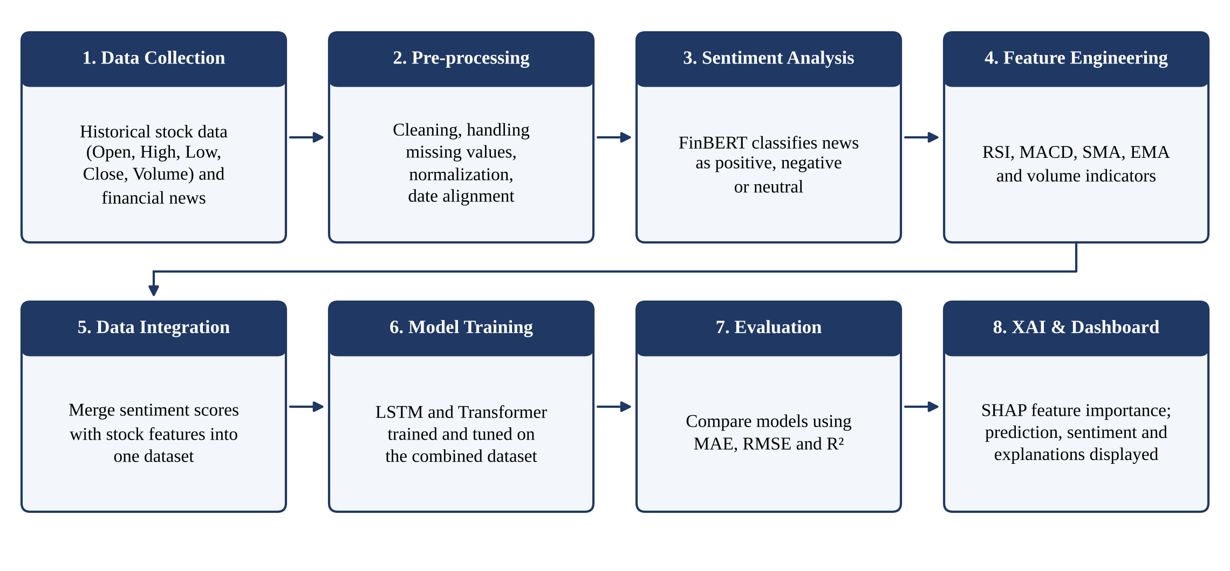
Fig. 4.1: Proposed methodology
- Data Collection: Historical stock data (Open, High, Low, Close, Volume) and financial news related to the selected companies are collected.
- Pre-processing: The data is cleaned, missing values are handled, features are normalised and stock and news records are aligned by date.
- Sentiment Analysis: FinBERT classifies each news headline as positive, negative or neutral.
- Feature Engineering: Technical indicators such as RSI, MACD, SMA, EMA and volume indicators are calculated.
- Data Integration: The sentiment scores are merged with the stock features into one dataset.
- Model Training: LSTM and Transformer models are trained and tuned on the combined dataset.
- Evaluation: The models are compared using MAE, RMSE and R².
- XAI and Dashboard: SHAP feature importance is computed, and the prediction, sentiment and explanations are displayed on the dashboard.

4.2 System Architecture
The architecture of the system, shown in Fig. 4.2, is organised into five stages.
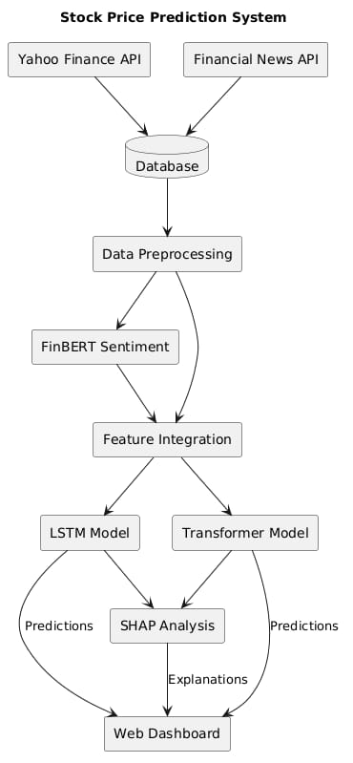
Fig. 4.2: System architecture
- Data Sources: Stock market data (OHLCV) and financial news headlines.
- Pre-processing: Cleaning, scaling and technical-indicator computation for market data; text cleaning and FinBERT sentiment classification (positive / negative / neutral) for news.
- Integration: Market features and sentiment scores are combined into the combined feature dataset.
- Prediction: The LSTM model and the Transformer model are trained on the combined dataset to predict stock prices.
- Output: Evaluation (MAE, RMSE, R²), SHAP explanation and a dashboard showing prediction, sentiment and explanation.

4.3 Use Case Diagram
The use case diagram of the system is shown in Fig. 4.3. It has two actors. The Investor / Analyst selects a company or stock, views the stock price prediction, views the news sentiment, compares the LSTM and Transformer models, and views the SHAP explanation. The Data Sources (market and news) actor provides the data used for the predictions and sentiment.
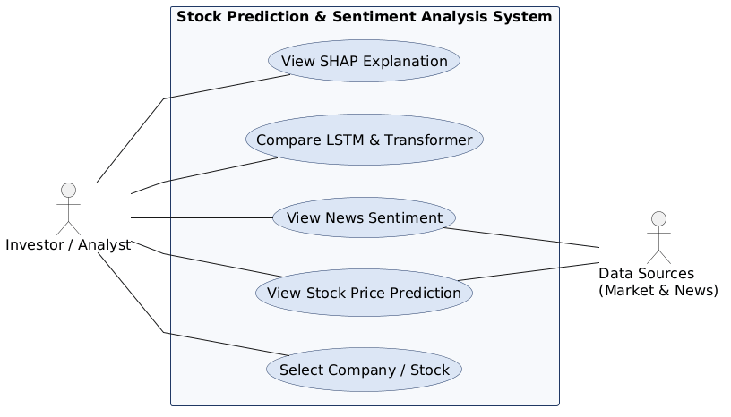
Fig. 4.3: Use case diagram

4.4 Activity Diagram
Fig. 4.4 shows the flow of activities. After stock data and news are collected, technical indicators and FinBERT sentiment are computed in parallel and integrated into the final dataset. The LSTM and Transformer models are trained and evaluated using MAE, RMSE and R². If the accuracy is not acceptable, the models are retrained and tuned; otherwise the SHAP explanation is generated and the results are displayed on the dashboard.
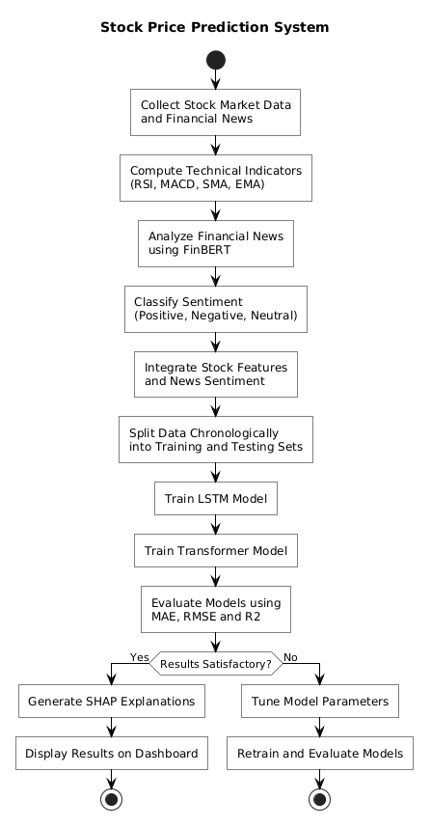
Fig. 4.4: Activity diagram

4.5 Sequence Diagram
The sequence diagram in Fig. 4.5 shows the interaction between the Investor, Dashboard, Data Collector, FinBERT Sentiment module, Prediction Model and SHAP Explainer. The investor selects a company; the dashboard requests stock data and news from the data collector, sends the headlines to FinBERT for sentiment scores, sends the combined features to the prediction model for the predicted price, requests an explanation from the SHAP explainer, and finally displays the prediction, sentiment and explanation to the investor.
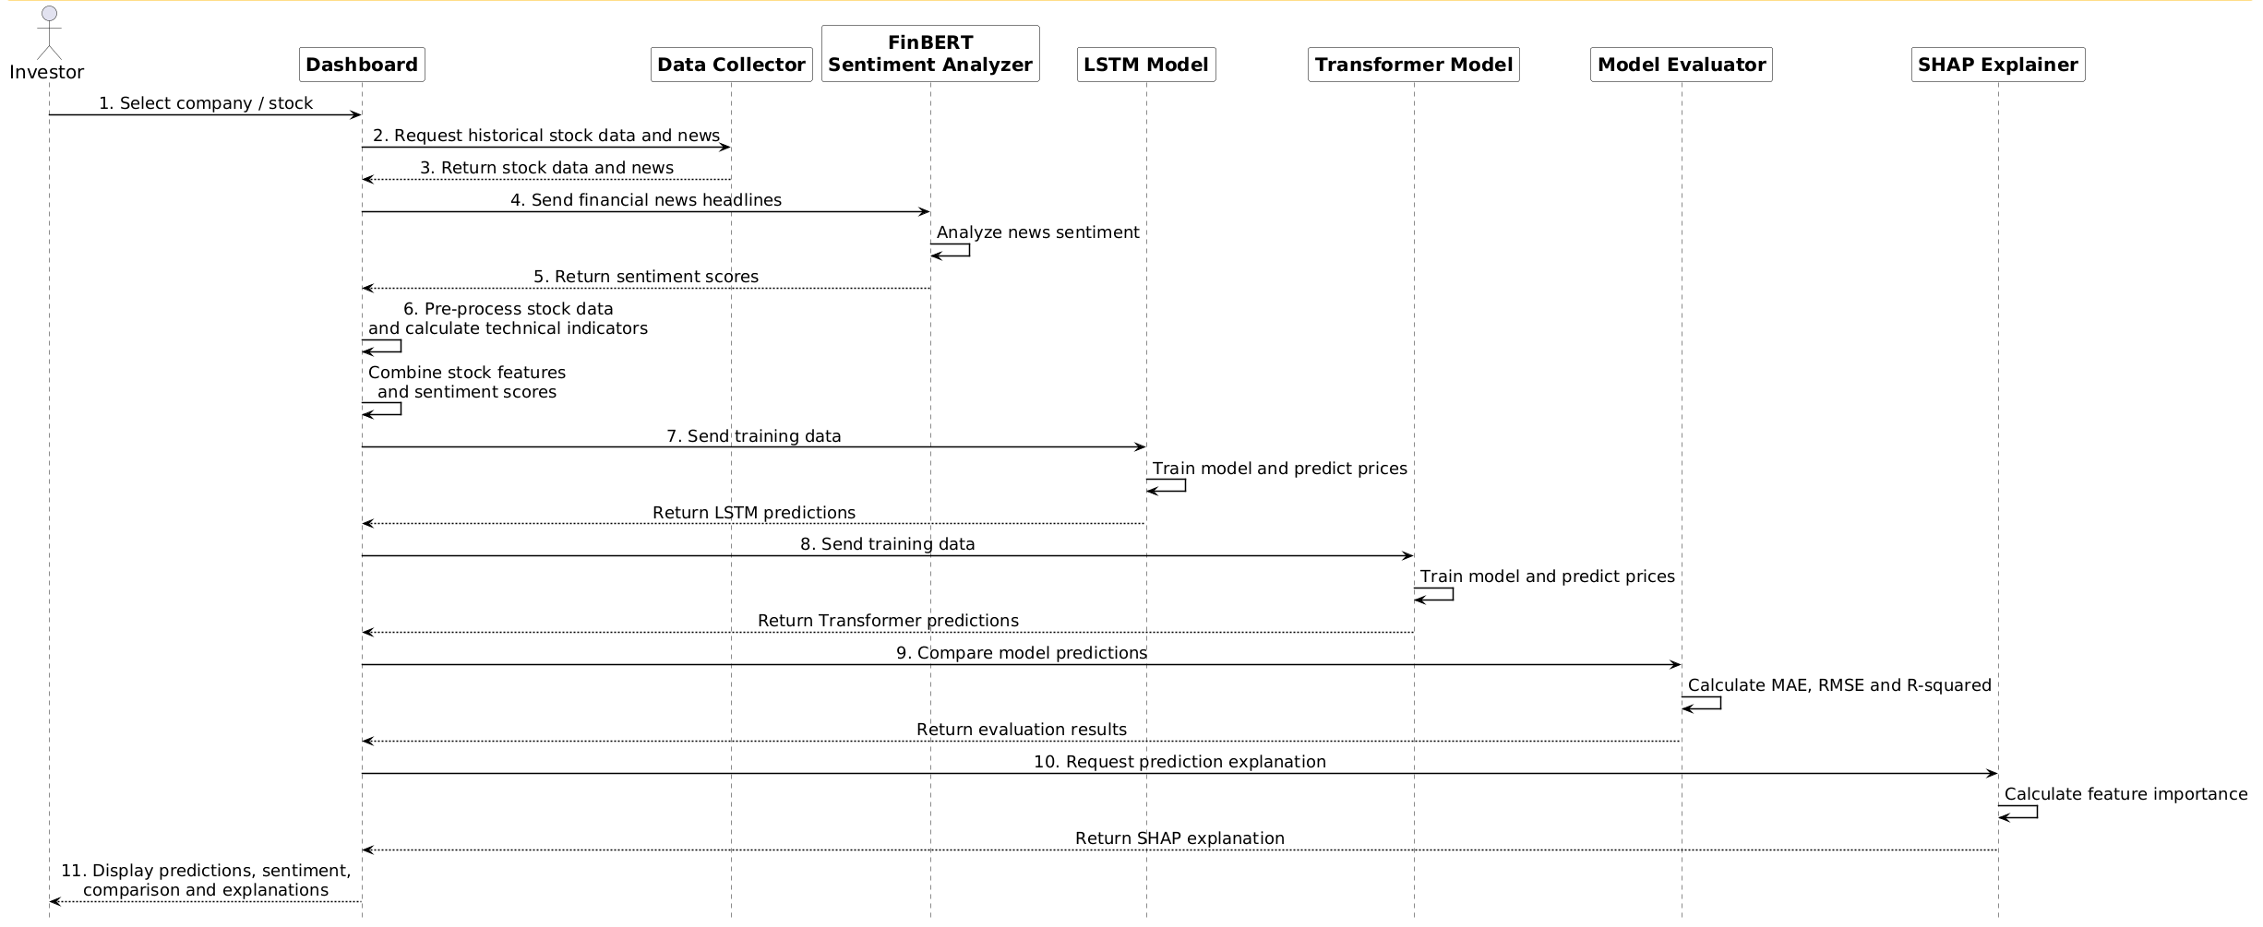
Fig. 4.5: Sequence diagram

4.6 Algorithm / Model Description
- Input: Historical stock data (OHLCV) and financial news headlines.
- Processing: Cleaning, normalisation and date alignment; technical indicators (RSI, MACD, SMA, EMA, volume); FinBERT sentiment classification; integration into one dataset.
- Algorithm: LSTM and Transformer deep-learning models, evaluated with MAE, RMSE and R², and explained with SHAP.
- Output: Predicted stock price, news sentiment, model comparison and SHAP-based explanation.
FinBERT
FinBERT is a BERT-based language model fine-tuned on financial text. It reads a news headline and assigns it to one of three classes, positive, negative or neutral, together with a confidence score. These scores are aggregated for each trading day and used as input features.
LSTM
Long Short-Term Memory is a recurrent neural network that uses gated memory cells to retain information over long sequences. It is well suited to time-series data such as stock prices, where the next value depends on earlier values over many days.
Transformer
A Transformer uses self-attention to weigh the importance of every time step in the input window relative to the others, instead of processing the sequence step by step. This allows it to capture long-range relationships in sequential financial data.
SHAP
SHAP (SHapley Additive exPlanations) assigns each input feature a contribution value for a given prediction, based on Shapley values from cooperative game theory. It is used to show which technical indicators, price features or sentiment scores pushed a prediction up or down.
Technical indicators and evaluation metrics
RSI measures the speed and size of recent price changes; MACD shows the relationship between two moving averages; SMA and EMA smooth prices over a chosen window, with EMA giving more weight to recent prices. Model performance is measured by Mean Absolute Error (MAE), Root Mean Squared Error (RMSE) and the coefficient of determination (R²).

4.7 Tools and Technologies Used
Table 4.1 lists the tools and technologies used for the project.
Component | Tools / Technologies
Programming Language | Python
Data Collection | Yahoo Finance (yfinance) for stock data; financial news APIs / datasets
Data Processing | Pandas, NumPy, scikit-learn, technical-analysis library (RSI, MACD, SMA, EMA)
Sentiment Analysis (NLP) | FinBERT using Hugging Face Transformers
Deep Learning Models | LSTM and Transformer using TensorFlow / Keras or PyTorch
Explainable AI | SHAP (SHapley Additive exPlanations)
Visualization & Dashboard | Matplotlib, Plotly, Streamlit
Development Environment | Jupyter Notebook / Google Colab

Table 4.1: Technology stack and tools

CHAPTER 5

IMPLEMENTATION PLAN FOR PROJECT STAGE – II

5.1 Module Structure
The work planned for Stage-II is divided into the following modules:
- Real-time stock data collection for continuous market analysis.
- Real-time financial news collection related to the selected companies.
- Sentiment classification using FinBERT (positive, negative, neutral).
- Technical indicators and data integration: RSI, MACD, SMA, EMA and trading volume, merged with news sentiment to create the final prediction dataset.
- Model training and tuning of the LSTM and Transformer models on the combined dataset.
- Model comparison using MAE, RMSE and R².
- Explainable AI using SHAP to identify which news and market features influenced each prediction.
- Dashboard development to display stock prediction, sentiment, model comparison and SHAP-based explanations, followed by testing and final documentation.

5.2 Project Timeline (Gantt Chart)
The planned implementation timeline for Stage-II is shown through the Gantt chart in Fig. 5.1
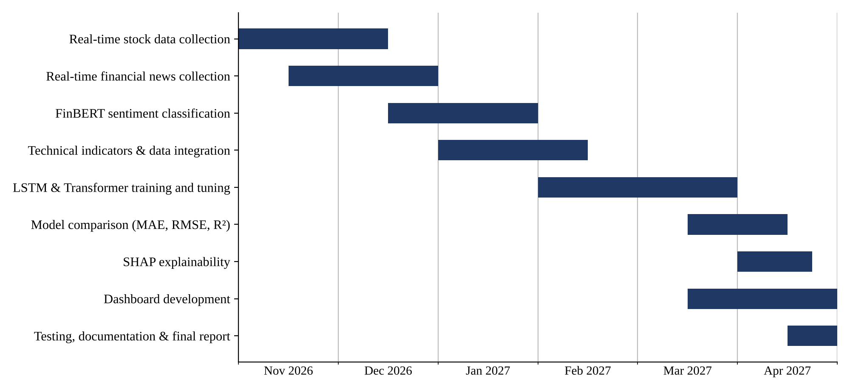
Fig. 5.1: Gantt chart of project implementation

Fig. 5.1: Gantt chart of project implementation

Table 5.1: Stage-II module schedule
Module | Planned Period
Real-time stock data collection | November – mid-December 2026
Real-time financial news collection | mid-November 2026 – December 2026
FinBERT sentiment classification | mid-December 2026 – January 2027
Technical indicators and data integration | January – mid-February 2027
LSTM and Transformer training and tuning | February – March 2027
Model comparison (MAE, RMSE, R²) | mid-March – mid-April 2027
SHAP explainability | April 2027
Dashboard development | mid-March – April 2027
Testing, documentation and final report | mid-April – end of April 2027

CHAPTER 6

EXPECTED OUTCOMES

Expected Outcomes
On completion of Stage-II the project is expected to deliver:
- A combined dataset of stock data, technical indicators and FinBERT news sentiment for the selected companies.
- Trained and tuned LSTM and Transformer models for stock-price prediction.
- A comparison of the two models using MAE, RMSE and R², identifying the more effective approach.
- SHAP-based explanations showing which news and market features influenced each prediction.
- An interactive dashboard displaying the stock prediction, news sentiment, model comparison and SHAP explanations.
Quantitative results will be reported after the models are trained and evaluated in Stage-II.

CHAPTER 7

CONCLUSION

Stock-price prediction is difficult because prices depend on both market behaviour and the information contained in financial news. The literature reviewed in this report shows that sentiment, technical indicators, deep-learning models and explainability each contribute to better prediction, but that they are rarely combined in one framework. This project addresses that gap by proposing an integrated and interpretable system that combines historical stock data, technical indicators and FinBERT sentiment, compares LSTM and Transformer models, and explains the predictions using SHAP.
In Stage-I, the problem statement, objectives, literature survey, research gap, methodology, system architecture and detailed design (use case, activity and sequence diagrams) have been completed, along with the selection of tools and technologies. Project Stage-II will focus on data collection, sentiment classification, model training and tuning, model comparison, SHAP explanation and development of the final dashboard.

REFERENCES
[1] J. Yang, Y. Wang, and X. Li, “Prediction of stock price direction using the LASSO-LSTM model combines technical indicators and financial sentiment analysis,” PeerJ Computer Science, vol. 8, e1148, 2022. doi: 10.7717/peerj-cs.1148.
[2] Y. Ayyappa, V. K. Bandarapalli, S. Padma Priya, S. Akhila, et al., “Forecasting Equity Prices using LSTM and BERT with Sentiment Analysis,” in 2023 International Conference on Inventive Computation Technologies (ICICT), 2023. doi: 10.1109/ICICT57646.2023.10134443.
[3] A. Kalra and R. Mittal, “Explainable AI for Improved Financial Decision Support in Trading,” in 2024 11th International Conference on Reliability, Infocom Technologies and Optimization (ICRITO), 2024. doi: 10.1109/ICRITO61523.2024.10522366.
[4] F. Moodi, A. Jahangard Rafsanjani, S. Zarifzadeh, and M. A. Zare Chahooki, “Fusion of Technical Indicators and Sentiment Analysis in a Hybrid Framework of Deep Learning Models for Stock Price Movement Prediction,” IEEE Access, vol. 12, pp. 195696–195709, 2024. doi: 10.1109/ACCESS.2024.3519556.
[5] E. G. A. Osman and F. A. Otaibi, “Integrating Deep Learning and Econometrics for Stock Price Prediction: A Comprehensive Comparison of LSTM, Transformers, and Traditional Time Series Models,” Machine Learning with Applications, vol. 22, 100730, 2025. doi: 10.1016/j.mlwa.2025.100730.
[6] T. Sidogi, R. Mbuvha, and T. Marwala, “Stock Price Prediction Using FinBERT and LSTM,” in 2021 IEEE International Conference on Systems, Man, and Cybernetics (SMC), 2021. doi: 10.1109/SMC52423.2021.9659283.
[7] D. Araci, “FinBERT: Financial Sentiment Analysis with Pre-trained Language Models,” arXiv preprint arXiv:1908.10063, 2019.
[8] O. Shobayo, S. Adeyemi-Longe, O. Popoola, and B. Ogunleye, “Innovative Sentiment Analysis and Prediction of Stock Price Using FinBERT, GPT-4 and Logistic Regression: A Data-Driven Approach,” Big Data and Cognitive Computing, vol. 8, no. 11, 143, 2024. doi: 10.3390/bdcc8110143.
[9] H. Yang, C. Ye, X. Lin, and H. Zhou, “Stock Market Prediction Based on BERT Embedding and News Sentiment Analysis,” in Service Science: Proceedings of the CCF 16th International Conference (ICSS 2023), Communications in Computer and Information Science, vol. 1844, pp. 334–348, 2023. doi: 10.1007/978-981-99-4402-6_20.
[10] T. Fischer and C. Krauss, “Deep Learning with Long Short-Term Memory Networks for Financial Market Predictions,” European Journal of Operational Research, vol. 270, no. 2, pp. 654–669, 2018. doi: 10.1016/j.ejor.2017.11.054.
[11] K. Olorunnimbe and H. Viktor, “Deep Learning in the Stock Market—A Systematic Survey of Practice, Backtesting, and Applications,” Artificial Intelligence Review, vol. 56, pp. 2057–2109, 2023. doi: 10.1007/s10462-022-10226-0.
[12] A. Thakkar and K. Chaudhari, “A Comprehensive Survey on Deep Neural Networks for Stock Market: The Need, Challenges, and Future Directions,” Expert Systems with Applications, vol. 177, 114800, 2021. doi: 10.1016/j.eswa.2021.114800.
[13] A. Vaswani et al., “Attention Is All You Need,” in Advances in Neural Information Processing Systems, vol. 30, pp. 5998–6008, 2017.
[14] S. M. Lundberg and S. I. Lee, “A Unified Approach to Interpreting Model Predictions,” in Advances in Neural Information Processing Systems, vol. 30, pp. 4765–4774, 2017.
[15] B. Lim and S. Zohren, “Time-Series Forecasting with Deep Learning: A Survey,” Philosophical Transactions of the Royal Society A, vol. 379, no. 2194, 20200209, 2021. doi: 10.1098/rsta.2020.0209.

